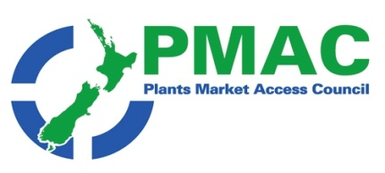
WEEKLY UPDATE: 05 September 2022

GOVERNMENT AGENCY NEWS

ICPR changes
The following ICPR have been updated in the last week
- French Polynesia has been updated with minor amendments to a number of commodities, as per ICPR amendment record. ICPR French Polynesia. Link to ICPR amendment.

WTO and TBT Notifications
Please find attached the most recent WTO and TBT notifications from countries that are considering changes to their plant import requirements for specific products. If you have any concerns about the notifications being presented, please contact Plant.exports@mpi.govt.nz so that they can potentially make a submission to the notifying country.

Subscribe/ Unsubscribe If you no longer wish to receive this email please send an email to info@pmac.co.nz asking to be added/ removed and providing the nominated email address
Disclaimer Please note this information has been accessed from emails that have been forwarded to info@pmac.co.nz and are distributed as a weekly update. If you intend using this information please sight the original document to ensure you are aware of the context within which any changes have been made and to guard against any transcription changes

