PMAC weekly update 27th July to 3rd August

- Government agencies: FYI on China Covid-19 import measures

- New Zealand News: Boost to agri-education with reopening of Taratahi; Primary sector jobs for kiwis gets a boost; New Zealand and Indonesia build ties in uncertain world; Tourism may have disappeared, but demand for NZ food is stronger than ever; New Zealand scientists share knowledge with their global peers; Musseling in on flower grower; Asia looms large for NZ avocados; Māori tech business creates app to streamline job matching for seasonal workers; Red Cross food and accommodation vouchers for Marlborough's overseas wine workers tops $10k; $50 million reforms to stop migrant worker exploitation; Airport plan excites NZ cherry growers, The End of a Golden Career

- International news: GAIN reports; UK Greening' requirement to end; Rivoira launches first zero residue apple; Bangladesh turns to imported fruits in pandemic; Maersk goes with the Flow; T&G backs joined-up strategy, 45% of American consumers have changed brand preferences during pandemic, study finds; The Supply Chain's Pandemic Playbook; Is soil-free farming the future?

Comments
Another interesting week with labour being the hot topic this week . From workers stuck in New Zealand , to the release of the Governments opportunity for all, to increased funding for training, to more inspectors to protect worker exploitation to the challenge of finding the right worker employment and labour has taken up a lot of media time over the last week. So much so about 50% of this weeks New Zealand articles are concerned with it.

There are a couple of other articles I’d like to point out today . The first involved a mussel extract company buying a cut flower producer in Christchurch to use their equipment to product rose extracts. Avery good example of value add especially in a sector that has been working hard to survive over the last few years as imported flowers have often undercut New Zealand produced flowers. The second article of interest is the marketing of a zero residue apple in Italy. With our Apples futures programme , over the last decade, New Zealand has been known for our very low residue apples . Similar to our apples the Italian apples do not claim to be absolutely chemical free but they do claim to have levels below the limit of detection .

- Agency news
  - FYI on China Covid-19 import measures
This FYI was released in mid-July to provide information about registration and declaration requirements for product into China. . It was released last week with the a number of change. The most significant is the addition of the following sentence “If a second wave of Covid-19 incidence occurs in New Zealand, it is China Customs’ expectation that exporters will immediately recall exports to China of any affected at-risk product, and suspend all exports to China until the risk has been successfully managed”. Full FYI available here

- New Zealand News
  - Boost to agri-education with reopening of Taratahi
The Government’s commitment to increase primary sector jobs and opportunities was further boosted last week with the re-opening of the Taratahi Agriculture Centre.

The Wairarapa-based training centre is reopening its doors after two years to deliver industry taster and familiarisation courses, to help workers displaced from other sectors into primary sector roles and lives. The Government is injecting $1.2 million into the programme to train 1,000 people, including providing wrap around job placement support. These training opportunities are part of the Government’s work to place 10,000 New Zealanders in primary sector jobs by rapidly retraining and absorbing displaced workers in sectors impacted by Covid. Another aspect is the website and marketing campaign - Opportunity Grows Here - that was launched this week to raise awareness of the career opportunities available in the food and fibre sector. Full article available here

  - Primary sector jobs for kiwis gets a boost
A new campaign launched last week will attract people to vital food and fibre sector jobs, says Agriculture Minister Damien O'Connor. The campaign Opportunity Grows Here – is a website and marketing campaign funded through Budget 2020 - to attract 10,000 New Zealanders into food and fibre jobs over four years.

It can be hard to find information when you are looking for a job and so we’ve built this site to bring opportunities across the primary sector together into the one place, making it easier for employers and for job seekers. Opportunities aren’t just in remote, labour-based roles. Some are jobs in our cities and include work in science, technology, business management, marketing and research. There is a really wide range of opportunities and we need people with a range of skills and backgrounds. Anyone interested in a primary sector career can discover more at opportunitygrowshere.nz Full article available here

  - New Zealand and Indonesia build ties in uncertain world
Foreign Minister Winston Peters and his Indonesian counterpart, Retno Marsudi, discussed navigating an uncertain world during the countries’ at a joint Ministerial Commission last week. At the meeting they took the opportunity discuss the impact of the COVID-19 pandemic in our respective countries and the wider region, and how we can work together toward trade and economic recovery.” At the meeting, Ministers Peters and Marsudi adopted the first Indonesia-New Zealand Plan of Action under the Comprehensive Partnership. The Action Plan maps a clear direction for our relationship for the period 2020-2024.

The Joint Statement released by New Zealand and Indonesia following the meeting is available here . In the statement they agreed to a number of areas including support of a free trade environment , regional security , climate change initiatives and the following trading target.To enhance mutual prosperity and strengthen trade and economic connections, the Ministers reaffirmed their commitment to increase two-way bilateral trade in goods and services to NZ$4 billion (IDR40 trillion) by 2024. They also reiterated their commitment to remove barriers that impede trade in order to achieve this target
Full article available here

Commentary
  - Tourism may have disappeared, but demand for NZ food is stronger than ever
Much of New Zealand’s economy might still be spluttering from the fallout of Covid-19, but exports of meat, dairy and horticulture products have been surging along in fine pre-pandemic fashion.
According to a report by the New Zealand Institute of Economic Research, agricultural export revenue from February 1 to June 24 this year is up nearly $1 billion on the same period last year – impressive results given the economic upheaval around the world and protectionism that’s unfolding in certain countries. While forestry, seafood and manufacturing exports were knocked to the mat and still haven’t recovered, dairy, meat and horticulture are up a spirited $713m, $80m and $292m respectively.
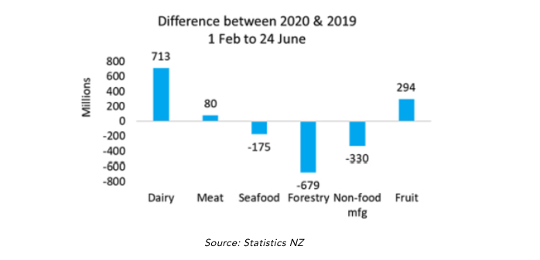
NZIER principal economist and author of the report Chris Nixon has credited the resilience of agricultural exports in part to New Zealand’s image as a source of clean, high-quality products and trusted institutions. With doubt and fear spreading as prolifically as the virus, it seems New Zealand’s brand is increasingly becoming a symbol of stability where overseas consumers know and trust what they’re getting.

However, it’s the enduring appetite of the Asian market – particularly China – that continues to drive the demand for New Zealand’s goods. Since 2017, China has been New Zealand’s largest trading partner. In the year ending December 2019, 23% of New Zealand’s total goods and services exports and 16% of imports by value were with China.

New Zealand has relied on such trade cards to extract it from an economic recession once before. Dr Murat Üngör, senior lecturer of economics at the University of Otago, said exports to the Asian market – particularly China – helped heave New Zealand out of recession during the GFC. “The 2008-2009 global financial crisis demonstrated how the New Zealand economy climbed out of the recession thanks to the export-led recovery. This was partly due to newly fostered trading relations between NZ, China and other Asian markets,” Üngör said.

Üngör said it’s plausible to expect that China continues being New Zealand’s major trading partner post-pandemic, but diversifying export partners and products remained an important strategy.
A telling point raised in the NZIER report is that no matter how much New Zealand relies on trade with China now, it is dwarfed by the dependence on the UK earlier in the 20th century.

According to the NZIER report, the strength of New Zealand’s trade relationship with China should allow “cautious optimism” around the continued export trend.
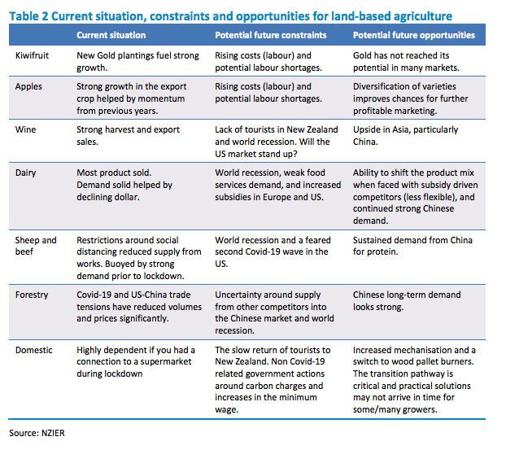
Of course, the longest shadow stretching over all of this is the pandemic, and how much it cripples economies across the world. “The continued persistence of Covid-19, particularly in the US and the United Kingdom, is a concern. How this plays out is very uncertain. It may affect US consumption of retail goods which could impact on Asian demand and, so, incomes. This means that they may have less to spend on New Zealand products and services,” the report said. Full article available here

In addition to this article this week the US gain reports had a reports specifically on NZ exports to China . This reports states :During the past decade, China has rapidly increased in its importance as a market for New Zealand agricultural and related products. While in 2009 China overtook the United States and Australia as the largest destination for New Zealand agricultural and related products, by 2019 shipments to China by value had reached quadruple the level of shipments to each of these next largest markets. A decade ago China accounted for only about 12 percent of New Zealand exports of these products, but last year this had reached 34 percent and this rapid growth has been among a wide range of commodities.

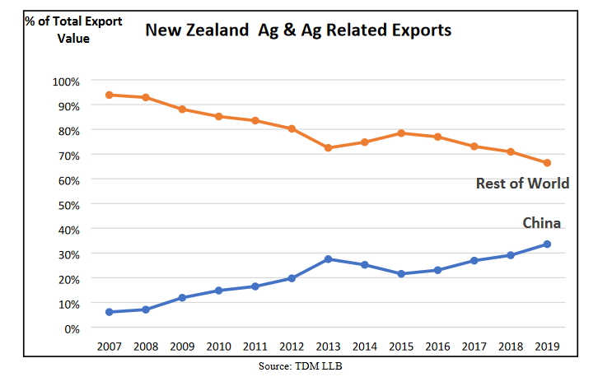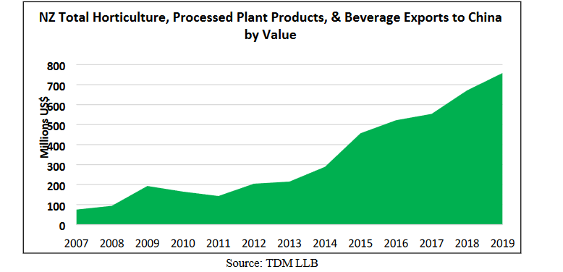
In addition to major exported products like dairy, beef, sheep meat, and wood – exports of horticultural products have also shown tremendous growth. Kiwi fruit exports are the single largest horticultural export to China, with all of the recent growth being driven by stronger exports of gold fleshed variety “Sun-gold”. Apple exports have also shown robust growth and is indicative of a larger trend of New Zealand apple exports shifting from Europe/North America and towards Asia. See New Zealand Agricultural Exports to China Continue to Surge_Wellington_New Zealand_07-20-2020

  - New Zealand scientists share knowledge with their global peers
Scientists in Aotearoa are collaborating and learning from experts across the globe about plants, pests and diseases. MPI, supported by Better Border Biosecurity (B3), has this year joined Euphresco, a global organisation comprising 50 countries that allows international experts to study and share information in the phytosanitary area.

Scientists from B3 and MPI are currently contributing to a dozen projects including Dr Chandan Pal, a senior scientist at MPI, who is investigating what kind of DNA we can find inside of plants.
"Euphresco has helped us build unique partnerships with our counterparts from other countries in plant health research area, and understand and build a common infrastructure required for research and innovation," said Dr Pal. Full article available here

  - Musselling in on flower grower
New Zealand’s biggest green-lipped mussel health food company has bought one of the country’s largest flower growing companies. Aroma NZ has bought Moffatt’s Flowers, which has been growing roses and other flowers in its Christchurch glasshouses since 1949. Aroma director Ben S Winters says it wants to diversify into different industry sectors because it makes sense not to have all they company’s products in one basket.

It is in the process of commercialising a new botanical extract derived from flowers and was looking for land and glasshouses for planting when the chance to buy Moffitt’s arose. “Having a mix of aquaculture and horticulture products extends our portfolio. It’s a great fit.” Aroma will maintain the existing flower business and plant about half a hectare in flowers for the new extract. Full article available here

  - Asia looms large for NZ avocados
Asian markets were a key growth driver for New Zealand avocado exports over the 2019/20 season.
According to figures released by peak body NZ Avocado, the industry exported 3.8m trays (5.5kg) over the 12 months to May 2020, an increase of 26 per cent year-on-year.

Asian markets – including Thailand, Korea, Singapore and Taiwan – received 35 per cent more volume than 2018/19, meeting the industry’s objective to grow sales in this region. Total industry returns for the 2019/20 season reached NZ$154m (US$102m), an increase of NZ$10m (US$6.6m) on the previous year. A record 2.7m trays were sold in the New Zealand domestic market, generating over NZ$50m (US$33m).
“For the first time in a number of years there was no break in avocado supply, as growers held on to one crop while the new crop matured on the trees,” NZ Avocado said in a release. “This also avoided the spike in pricing that often accompanies the lower supply but increasing demand.”

Investment in new plantings continued in 2019, with over 120 new avocado properties registered in New Zealand between May 2019 and May 2020. In a bid to reduce the impact avocado production has on the land, NZ Avocado is developing a sustainability strategy and has hosted a series of stakeholder workshops around the country’s avocado growing regions.

The new-season crop appears to be shaping up well, with NZ Avocado tipping a 10-15 per cent increase in volume from 2019/2020. Full article available here

  - Māori tech business creates app to streamline job matching for seasonal workers
Gisborne entrepreneur Candice Pardy has created an app that simplifies the process of connecting seasonal workers with employers. A new app that connects seasonal workers with horticultural employers promises to streamline the hiring process.

Pardy developed the Jobloads app during lockdown, after her first app, Carloads, which connected workers with transport options was thwarted by social distancing rules.While Carloads was now on the back burner it would eventually become part of the service Jobloads offered, she said. The app was free to use for jobseekers and provided businesses with a more streamlined approach to hiring.

Job seekers went through a three stage-screening process to make sure they were a good fit and that they were ready to work. The screening picked up if a person faced any particular barriers to work including not having a reliable ride, running out of data on their phone or not being able to afford petrol – and helped overcome them. “In that regard we are social platform,” she said.

Jobloads, which connects seasonal workers with employers, is in the early stages of starting up and is going through a seed funding round.Job seekers could interact with a free bot if they had no mobile phone credit or data. The app would also provide transparency for workers, including the amenities that would be provided by the employer, the pay rate and working conditions. This would help weed out “cowboy contractors” and worker exploitation, she said.

On the employer side, they would understand the goals of that worker through reading a profile before employing them.“We know that the challenge growers face is finding that reliable local worker. We surveyed heaps of growers. Everyone said the same thing – they prefer RSE (Recognised Seasonal Employers) workers. The app will recognise workers that formed good habits like working all their scheduled shifts, being punctual and learning new skills, Pardy said. The app will be rolled out nationally after October, she said. Full article available here

  - Red Cross food and accommodation vouchers for Marlborough's overseas wine workers tops $10k
An article on the dilemma facing many overseas visitors who have been working in the Wine Industry who are now without work and unable to work because their VISA is tied to a single employer. and they are unable to return to their home countries.

A petition, launched by Cait Guyette, who was from the United States but had a permanent job at a winery in Blenheim, had called for the Government to ease visa restrictions. The petition closed on July 1 and was still to be presented in Parliament. “There's not a lot of need in the winery for workers at the moment. What I’m hoping is that they will remove the conditions on the visas because they’re tied to the employer,” Guyette said.
“
But if they made them more like a working holiday visa, that would allow people to work in other industries, in vineyards and other agriculture industries. Especially for South Americans that are still unable to get home.” Immigration New Zealand border and visa operations general manager Nicola Hogg said a further six-month extension for some temporary work visa holders provided both migrants and employers with more certainty in the short term.

“In general, INZ’s advice to people who are here from overseas, who are not currently employed, and are experiencing financial difficulty during COVID-19 is to talk to their embassy or consulate for assistance.” More information could be found at https://www.redcross.org.nz/stories/new-zealand/visitor-care-manaaki-manuhiri/ and people could apply at https://foreignnationals.services.govt.nz.
Full article available here

  - $50 million reforms to stop migrant worker exploitation
Exploitation of migrant workers across New Zealand is rampant, according to advocate Nathan Santesso. He assists workers with their claims of exploitation, and helps them take employers to the Employment Relations Committee, or the Employment Court. He said migrants are often and easily abused because of how vulnerable they are in a foreign country, with little money and no support network.

The reforms announced by the Government on Monday look to amend that dependence. .A new visa is to be created, which will allow migrants to leave their employer, without it negatively affecting their immigration status. Some measures are aimed at giving migrants the platform to speak out against their employer, such as a free phone number and an online reporting system.

Other measures look to punish those who are caught. They'll be banned from managing a company and won't be able to hire migrant workers in the future. Minister for Workplace Relations and Safety Andrew Little said they would recruit new labour inspectors as well.

Hiring more inspectors is being welcomed by the head of NZ Kiwifruit Growers (NZKGI), Nikki Johnson.
Just under 20 per cent of their seasonal workers are from the Pacific Islands on the Recognised Seasonal Employer programme, and a further 25 per cent are backpackers on Working Holiday visas.
She said they had been calling for more resources for some time. "While as an industry we can do some things, we actually need the Government to be able to play their part in the true enforcement section.
"
New immigration and employment infringement offences targeting non-compliant employer behaviour is scheduled to be introduced at some point as well.

Gary Jones of NZAP however notes "My view is that we need independent third party assurance platforms that are transparent that work with MBIE officials and the inspectorates to target their resources to where we think there are exploitative behaviours. "The changes will be implemented from next year, with the 0800 reporting line and new visa in place by mid-2021. Full article available here

Airport plan excites NZ cherry growers
New Zealand’s cherry growers have welcomed a proposal for a new airport in Central Otago, the country’s main cherry growing region. Christchurch International Airport revealed it has begun discussions on potentially building an international airport on 750ha of land near Tarras, which lies one hour northeast of Queenstown and over four hours southwest of Christchurch.

According to a report from the New Zealand Herald, cherry growers expressed their enthusiasm about the airport at a public meeting held in Tarras. Tim Jones, chairman of Summerfruit NZ, said the airport’s ability to take wide-body jets would be key. Jones expected said Central Otago’s crop could reach 10,000 tonnes a season, up from around 2,500 tonnes in recent years, and cargo space in passenger jets would not be enough. Full article available here

  - The End of a Golden Career
Russell Lowe has spent almost 50 years selecting, observing, propagating and tasting kiwifruit at Plant and Food Research in Te Puke. Earlier this year Russell was recognised for his role in developing Zespri's SunGold kiwifruit.

Forty-eight years ago, research scientist Russell Lowe moved to Te Puke to work at the DSIR's new research orchard. Russell is credited with helping develop both Hort 16A, New Zealand's first export gold kiwifruit and SunGold, the fruit it was replaced with when the disease PSA hit. Full article available here

- International news

Comment
  - GAIN reports
Gain reports are from the “Global Agricultural Information Network” and are produced by the USDA. They are designed to provide timely information on the economy, products and issues in foreign countries that are likely to have an impact on United States agricultural production and trade. The information in them is written for USA exporters but the majority is equally relevant to New Zealand. With regard to import regulations for a particular market New Zealand exporters should first check the countries ICPR on MPI’s web site. These are collated specifically for New Zealand product. However the Gain reports often provide additional information that is useful e.g. on grading and labelling, economic profiles. To see the full report click on the link in each notification This week see:

- Bosnia and Herzegovina Food and Agricultural Import Regulations and Standards Country Report Food and Agricultural Import Regulations and Standards Country Report_Sarajevo_Bosnia and Herzegovina_06-30-2020

- Bosnia and Herzegovina Food and Agricultural Import Regulations and Standards Export Certificate Report Food and Agricultural Import Regulations and Standards Export Certificate Report_Sarajevo_Bosnia and Herzegovina_06-30-2020

- China Notifies Draft Maximum Residue Limits of Pesticides in Foods as SPS 1164
On July 15, 2020, China notified 589 maximum residue limits (MRLs) on 67 pesticides in foods to the World Trade Organization SPS Committee as G/SPS/N/CHN/1164. The draft MRLs cover a range of horticultural products. The deadline for comments is September 13, 2020. China Notifies Draft Maximum Residue Limits of Pesticides in Foods as SPS 1164_Beijing_China - Peoples Republic of_07-22-2020

- France Retail Foods The retail sector fared well during the COVID-19 pandemic. Retail Foods_Paris_France_06-30-2020

- Romania COVID-19 Transforms Romanian Retail and Food Service Sectors
Since Romania’s first COVID-19 case on February 26, 2020, Romanian consumers have dramatically shifted away from shopping in traditional markets and modern retail outlets in favor of online shopping. COVID-19 Transforms Romanian Retail and Food Service Sectors _Bucharest_Romania_07-22-2020

- Saudi Arabia Retail Foods Retail Foods_Riyadh_Saudi Arabia_06-30-2019

- Thailand The Voluntarily Use of a Certificate of Analysis for Fresh Produce Exports to Thailand This report explains the required information for the optional certificate of analysis for fresh produce exports to Thailand. The Voluntarily Use of a Certificate of Analysis for Fresh Produce Exports to Thailand_Bangkok_Thailand_07-24-2020

- Ukraine FAIRS Annual Country Report Annual FAIRS Annual Country Report Annual_Kyiv_Ukraine_06-30-2020

- Ukraine Food and Agricultural Import Regulations and Standards Export Certificate Report
Food and Agricultural Import Regulations and Standards Export Certificate Report_Kyiv_Ukraine_06-30-2020

Regulatory
  - UK Greening' requirement to end
The UK government is to end the requirement to comply with EU greening requirements in a move it says will reduce red tape for farmers. The European Commission’s so-called greening requirements for direct payments have required farmers to carry out specified practices in order to qualify for additional payments.
Under government plans to simplify the Basic Payment Scheme (BPS) and cut red tape faced by farmers during the agricultural transition period, farmers will have a reduced administrative burden and will no longer have to comply with the greening requirements with effect from the 2021 scheme year.
The agricultural transition period will last for seven years and see direct payments to farmers in England phased out and replaced with a new system that rewards farmers for delivering public goods, such as tree or hedge planting, river management to mitigate flooding, and creating or restoring habitats for wildlife. The new Environmental Land Management scheme, expected to be rolled out in late 2024, will introduce new ways of working together with farmers to deliver better environmental outcomes and reverse the decline of some of the country's most cherished species. Full article available here

Business/ Industry
  - Rivoira launches first zero residue apple
Italy’s Rivoira Group is preparing to harvest its first crop of ‘zero residue’ apples. The Gala apples were grown as part of the company’s Rivoira Zero project to develop production techniques delivering premium and sustainable product certified as chemical-free. The company said the apples contain pesticide residues below the analytical detection limit, or less than 0.01ppm.

“This will serve to further segment our offer by creating an intermediate category lying between conventional and organic, providing a new price range for consumers and higher returns for growers.”
Rivoira said the project covers “every detail of the production processes right along the supply chain, which is managed by a team of technical experts and verified by certified laboratories”. Full article available here

  - Bangladesh turns to imported fruits in pandemic
Bangladesh fruit imports since January have increased nearly 20 per cent year-on-year with demand growing as consumers look for healthy foods. According to Bangladesh’s customs department, 213,106 tonnes of kinnows, apples, oranges, grapes and pears were imported between January and June, a 19.18 per cent increase year-on-year. Consumers were also willing to pay more for these fruits with the value of imported fruits increasing by 23.37 per cent over the same time. Imports account for more than half of the county’s fruit consumption. Full article available here

  - Maersk goes with the Flow
In a bid to further assist small and medium sized businesses with the complexity of managing their supply chains, logistics specialist Maersk has launched Maersk Flow, a digital platform which provides customers and their partners with "everything they need to take control of their supply chain, from factory to market".

According to Maersk, the solution enables transparency in critical supply chain processes and ensures that the flow of goods and documents is executed as planned. It also reduces manual work and costly mistakes, the group said, while empowering logistics professionals with all the current and historical data they need to sustainably improve their supply chain. Full article available here

  - T&G backs joined-up strategy
According to Steve Maxwell is the chief executive of New Zealand-based T&G Global’s UK subsidiary, Worldwide Fruit, and managing director of its European unit, Enzafruit Continent. T&G’s strategy is to be more involved in the ownership of the brand, including plant variety rights. It’s a very joined-up, end-to-end strategy. It involves working with the right growers and then selling the fruit to the right places without compromise. It’s about believing in a variety and being determined to do everything to give the customer that same quality again and again. It allows you to build a 52-week programme quickly.
Like Jazz and Envy, Gala and Braeburn also came out of New Zealand. So out of all the global success stories in apples over the last 50 years, only Pink Lady has come from somewhere other than New Zealand. The country has had a real commitment to researching new varieties, which is a laborious process, endlessly crossing and crossing.
The effect of Covd19 The supply chain has been more robust than we all feared it would be at the start of the pandemic. A lot of hard work has been done across production, packing, logistics and retail - we’ve done really well to have such minimal impact. Unfortunately, it can’t help but increase costs, but we in apples are less worried about labour at the moment since we don’t start picking until closer to September. Amazingly, we have sold more this year. People are looking out for their health, and apples are a very solid purchase in the shopping basket. They last over a week so you can buy them with confidence, including online. Full article available here

  - 45% of American consumers have changed brand preferences during pandemic
The COVID-19 pandemic and recent racial justice issues have changed the brand preferences of 45% of consumers, according to a new report from communications firm Ketchum. The report identified four pandemic personas: retro reengagers, open-minded explorers, worried withholders and cautious questioners.62% expect their brand preferences will change permanently before the pandemic subsides. Additionally, 88% said the coronavirus has made it more important for companies to be ethical, and 90% said they prefer to buy from businesses that prioritize customer and employee safety.

The retro reengagers, 33% of consumers, want to return to normal. These politically conservative consumers are comfortable going to public spaces, think face masks should not be required and are less likely to prioritize diversity and inclusion, per Ketchum.

On the other hand, open-minded explorers (22%) want to see a more progressive world when things reopen. These urbanites tend to be well-educated and influenced by advertisers, social media and bloggers, Ketchum's report notes. They are most likely to change brands post-pandemic based on companies' actions during the health crisis.

The worried withholders, 20% of consumers, prefer to stay in their comfort zone and are not comfortable in public spaces during the pandemic. These older, centrists/conservatives are not easily influenced by advertising, according to Ketchum. This group is least likely to have changed their brand preferences during the pandemic.

Cautious questioners, 25% of consumers, tend to be politically liberal. These people keep their distance and are twice as likely than the average American to feel very uncomfortable visiting shared spaces. They prefer to buy from brands that support diversity and inclusion in response to the recent protests. Full article available here

  - The Supply Chain's Pandemic Playbook
The initial outbreak of COVID-19 in the United States rocked the supermarket world unlike anything else in modern times. Behind the frantic scenes of shoppers fighting over toilet paper, the grocery supply chain was being stretched and bent like never before. This article makes comment about the importance of managing the supply chain . Its written from a retailers perspective and provides several good examples of how businesses adapted during the pandemic

Key Takeaways
- The coronavirus pandemic has revealed vulnerabilities in the supply chain that the food retail industry must figure out how best to address.
- Demand planning and inventory management solutions, enhanced by machine learning, can bring greater visibility to the supply chain.
- Companies should also focus on stronger collaboration with suppliers and other partners, both within and outside the industry, and on developing a cross-functional workforce.
“COVID-19 really raised the importance of the supply chain,” observes Tom Madrecki, VP of supply chain for the Consumer Brands Association (CBA), also based in Arlington. “It went from being an issue that was maybe not front and center within the c-suite or within government to being the issue of the moment.”

Now that the pandemic’s initial outbreak has passed, the industry has a brief window of time to reflect on what worked, what went wrong, and ultimately how to plan ahead for what’s next. While no one can predict the future precisely, one thing’s for certain: Retailers need to be prepared as much as possible and focused on building a more resilient supply chain to adapt to whatever comes their way.

Here are key areas that they can focus on to make their supply chains as COVID-proof as possible, according to Griswold and other industry watchers:
- Build in more agility and flexibility;
- Increase the frequency of supply chain modeling;
- Work to more quickly adopt new technologies that can aid in visibility, planning and beyond;
- Better collaborate with suppliers and other industry partners, and rethink supplier diversification;
- Focus on a well-protected, more cross-functional and flexible labor force; and
- Reconsider the balance of in-store versus online sales, with a specific focus on last-mile delivery.

For example Going forward, Walmart will be “accelerating how often and how fast” the company does supply chain modeling and network design, he added. “We’re looking at scenarios that we never contemplated before. We’re doing a lot of worst-case scenarios about turning off different nodes if they’re impacted, and how we’d react to that.”

“There are a lot of technology and processes that can be implemented faster than anyone would have said was possible last year.” He cited examples such as the ability to onboard an associate in under 24 hours, as well as starting up a warehouse management system in a matter of days, as opposed to weeks or months, to get a new distribution center operational. Full article available here

  - Is soil-free farming the future?
Soil-free, computer-controlled farms could offer a solution for future crop growing as climate change and soil erosion limit farmers' ability to grow, new research has claimed. An interdisciplinary study in the UK combining biology and engineering identifies future research areas needed to increase the sustainable growth of vertical farming using precision agriculture, including aeroponic cultivation methods which uses nutrient-enriched aerosols in place of soil that are applied directly to the roots.

This method is believed to resolve many of the physiological constraints that occur using hydroponic systems, such as improved aeration around the roots, meaning yields of up to 70 per cent greater can be achieved. However, the systems need extensive farm infrastructure and control technology.

The report argues that a driver of technological innovation in vertical farms is minimising operation costs whilst maximising productivity, and that investment in fundamental biological research has a significant role. Therefore, the researchers are looking to understand:
  - Why aeroponic cultivation can be more productive than hydroponic or soil cultivation;
  - The relationship between aeroponic cultivation and 24-hour circadian rhythms of plants;
  - Root development of a range of crops in aeroponic conditions;
  - The relationship between aerosol droplet size and deposition and plant performance;
  - How we can establish frameworks for comparing vertical farming technologies for a range of crops;
  - How aeroponic methods affect microbial interactions with plant roots;
  - The nature of recycling of root exudates (compounds secreted by the roots of plants) within the nutrient solutions of closed aeroponic systems.

During the current global pandemic vertical farms in Dundee have demonstrated on a small scale how this type of farming can be an important component of a reliable food supply chain amidst shortages, according to researchers. However, they stress that knowledge gaps remain and this study highlights the future research needed to understand how plants grow and respond during aeroponic cultivation. “Full article available here

Subscribe/ Unsubscribe If you no longer wish to receive this email please send a note to info@pmac.co.nz asking to be added/ removed and providing the nominated email address

Disclaimer Please note this information has been accessed from emails that have been forwarded to info@PMAC.co.nz and are distributed as a weekly update. If you intend using this information please sight the original document to ensure you are aware of the context within which any changes have been made and to guard against any transcription changes

